

Longitudinal Study
EDUCE
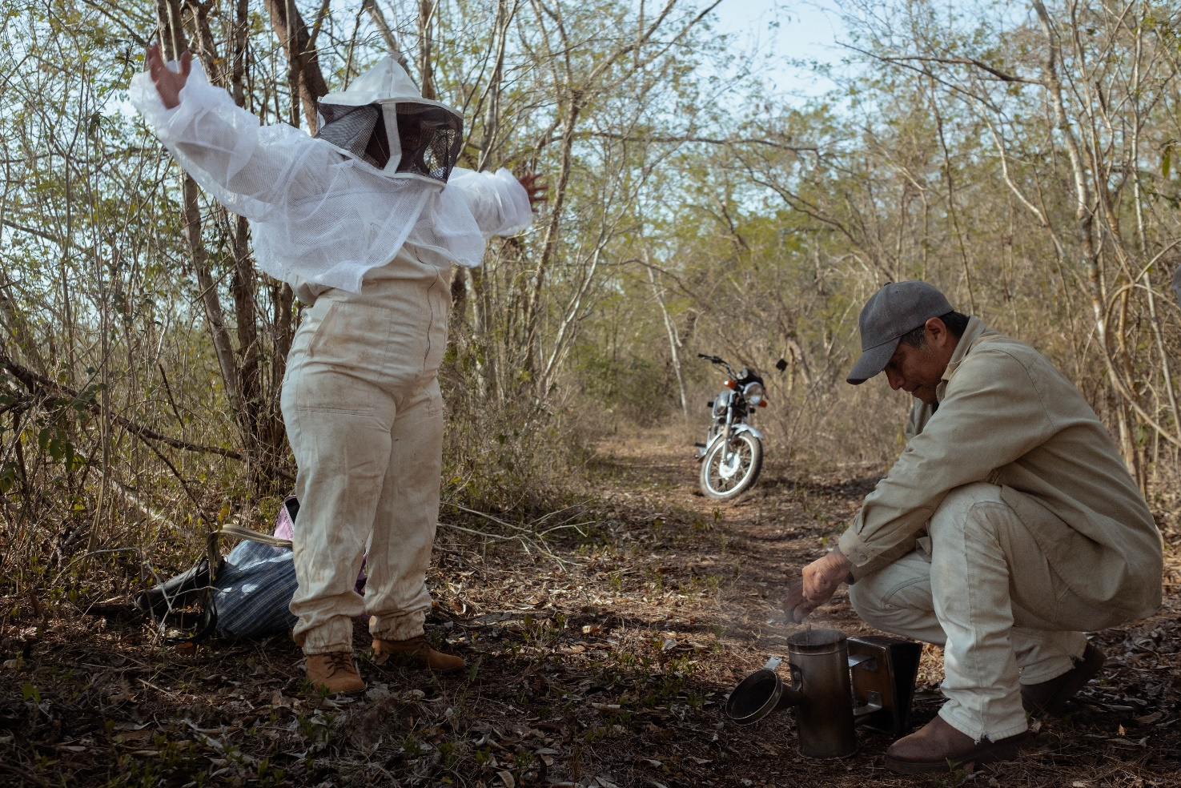

María Colli gets ready to enter her apiary while her husband, Diego Colli, prepares the bee smoker.
Diego is the leader of the local co-op and has also been a mentor for María and the other women interested in becoming beekeepers.
“The product we produce has a history. It comes from the Mayan territory and Mayan people who have a centuries-long tradition of caring for the land.
By buying our honey you are helping to continue that tradition.”
EDUCE Founder and Managing Director Miguel Ángel Munguìa

Contents
Acknowledgements 3
Methodology 3
Why we measure impact 4
Background 5
EDUCE 8
EDUCE co-operatives 9
Business growth 10
Sustainability and impacts of climate change 13
Social impact 16
My story: Andrés Munguía Zarco, Treasurer 18
My story: Juan Orcanza, Finance Manager 19
My story: María Colli, Beekeeper 20
My story: Jorge Alberto Chan López, Beekeeper 22
Plans for the future 23
Conclusion 24
Glossary 25
Appendix 1: Producer survey 26
Appendix 2: Sample interview questions 27

Acknowledgements

This study and report have been prepared and written by Laura Gabriele.
Our sincere thanks to Miguel Ángel Munguìa, Founder and General Manager of EDUCE, for giving permission for this case study and support with data gathering. Our thanks go to Nick Regan at the University of Bath, for his support to interpret the interviews. We are also grateful to Shared Interest volunteers Alejandra Lopez Rojas for translation and transcription of a selection of short films, Colin Corkerton and Elody Alcaraz for carrying out background research and Peter Jones for supporting with data entry. We also express our gratitude to producers and employees from EDUCE, visual creator Alejandra Rajal who captured images and film of EDUCE contributors included in this study, and team members from Shared Interest, who made this study possible.

Methodology

This study involved a mixed method of investigation, which included both quantitative (survey of producers) and qualitative (semi-structured interviews) methodologies. With EDUCE’S support, we were able to carry out a sample survey with 120 of their members, representing 13.5% of their total membership, to understand more about their relationship with the co-operative. Surveys were carried out in Spanish and using pen and paper. Interviews were carried out with eight individuals at EDUCE, including those performing a selection of key roles – the General Manager, Treasurer and Finance Manager. Interviews were also carried out with two beekeepers to give a more detailed understanding of their experiences. All interviews were carried out remotely using Microsoft Teams video calling and involved simultaneous interpretation with the support of an interpreter. Interviews were recorded, with the permission of all participants, and later transcribed to enable the extraction of the quotes used in this report.

Secondary data collection was also carried out in the form of desktop research to learn more about the commodity, region and context of the co-operative. We have also reviewed all available documentation we have about EDUCE, such as loan proposals, annual reviews, financial reports and visit reports to support the study and the development of the graphs in this report.

A sample of the survey and interview questions can be found in the appendices to this document.

Why we measure impact
Shared Interest Society is an ethical investment organisation offering fair finance to producers and buyers across the globe. Our model enables over 12,000 individuals to come together and make a positive difference by contributing to social change. These members pool their funds and make a much larger impact than they would be able to achieve individually. Last year, these combined investments totalled £52.3m and this enabled us to make disbursements totalling £51.9m to 204 organisations in 45 countries, improving the livelihoods of 388,320 farmers and artisans in some of the world’s most disadvantaged communities.
In 2004, Shared Interest Society established a subsidiary, Shared Interest Foundation. The charity delivers technical assistance, business support and climate mitigation and adaptation projects with small-scale producer organisations and community groups across Africa and Latin America.
Our mission is ’to provide financial services and business support to make livelihoods and living standards better for people as they trade their way out of poverty. We work collaboratively and innovatively with those who share our commitment to fair and just trade. With a community of investors and the support of our donors and volunteers, we seek to contribute to a world where justice is at the heart of trade finance.’
Our monitoring and evaluation process involves portfolio-wide social and financial due diligence, and case studies of the organisations we support. Our regional teams maintain regular contact with the producers, organise producer committees and surveys and undertake annual reviews.
In 2015, we began to supplement our social and environmental metrics with deeper studies of selected customers and project beneficiaries to evaluate whether and how these businesses support farmer and artisan livelihoods and offer a justifiable account of our contribution to this.
These case studies are primarily intended to demonstrate two levels of impact: that of our financial support to producer organisations, and the wider impact on the livelihoods of the smallholder farmers or artisans they serve. We qualitatively describe other types of impacts on their communities, as well as on the surrounding environment. Finally, we situate these impacts within the broader context of the country and value chain, to illustrate how these businesses, end-buyers and social financiers like Shared Interest work together to grow rural prosperity for smallholder producers and their communities.
These studies enable us to better understand both levels of impact (enterprise-level and household-level) and provide both Shared Interest and our customers with the information necessary to continuously improve our services. We are grateful to the contributors who share their stories and lived experiences, so that we can understand this impact as fully as possible.

Background
Honey
For Mayan communities, bees and their honey have always been sacred. The Mayan word for ‘bee’ is ‘kaab’ and this can also be translated as ‘world’, ‘land’ or ‘force’. The bee itself is recognised as a symbol of fertility and abundance with many communities in the region holding ceremonies to ask bees for permission to harvest their honey. They then thank the bees for their generosity. But for the Mayan producer-members of the EDUCE co-operative, honey is both their cultural heritage and their livelihood.
Mexico is the world's fifth-largest exporter of honey, and therefore the socioeconomic implications of beekeeping in the country are far-reaching, with roughly 43,000 beekeepers producing around 61,000 tons of honey annually, equating to a commercial value of 67.9 USD million dollars. This is reinforced by the high demand for Mexican honey on the international market, with European countries such as Germany, Belgium and Switzerland unable to meet production demands for their population.
The honey produced in the region is harvested using traditional methods, which involve the use of small wooden boxes called "cajas" which house the bees and collect the honey. The cajas are placed in areas with abundant flowering plants, and the bees are left to forage and produce honey at their own pace. Once the honey is ready, it is extracted using simple tools and techniques, with minimal disruption to the bees and their habitat.
EDUCE General Manager Miguel states that for each kilo of honey marketed as Fairtrade, an additional 20 cents are paid to the farmer through the Fairtrade Premium. This represents 1.50 to 2 pesos per kilo of honey, the equivalent of 0.07p to 0.09p. This production goes to an exclusive market in Germany and Switzerland, mostly. As for the product itself, EDUCE’s honey is distinguishable for its purity and for the variety of the vegetation and the climate of the region. The honey is produced in special and protected areas away from the use of pesticides.
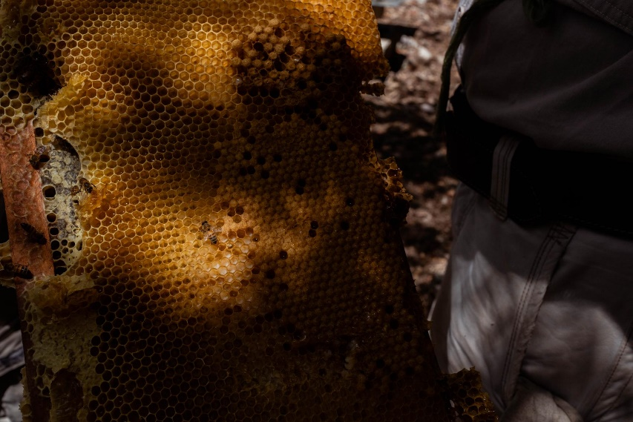
As the business grows, EDUCE continues to work with community leaders to promote cultural exchanges among its members to ensure the indigenous knowledge around beekeeping is not lost. EDUCE also works with producers to preserve indigenous flowers that give Yucatecan honey a taste that cannot be reproduced anywhere else in the world. Over 2,000 flower species are situated in Mexico, and this can be credited to the unique, favourable climate which fosters a diversity of plants and ecosystems. In turn, the
above-average yields obtained by EDUCE are a direct result of their efforts to preserve the richness of the environment, in the face of intensifying climate change, which supports the quantity and productivity of pollinators.
A honeycomb is checked before the beekeepers decide to extract honey from it.
Mexico
For many producers in the Yucatán Peninsula of Mexico, beekeeping is one of the main sources of economic income. Other activities such as cornfields and family gardens are present, however, they exist for subsistence. One of the key challenges that beekeepers face is the commercialisation of honey at low prices.
In Mexico, there are 40 UNESCO World Network Biosphere Reserves which function as long term refuges for biodiversity. According to the United Nations, climate change is playing an increasingly important role in the decline of biodiversity, altering marine, terrestrial, and freshwater ecosystems around the world. Specifically in beekeeping, alterations in rainfall patterns and drought events, interspersed with an increased frequency of natural phenomena such as hurricanes and storms, represent a destabilising factor for beekeeping because flowering periods are becoming increasingly unpredictable.
This unpredictability makes it increasingly difficult for beekeepers to harvest the same amount of honey each year, as they must coordinate and anticipate the flowering time to ensure that hives are ready for honey harvesting. This poses a serious challenge to the farmers, who are threatened with losing a significant portion of their income.
The regions of Yucatán Peninsula and Veracruz represent 45% of Mexico’s total honey production and have been identified as ‘stand out’ areas with the highest incidence of natural phenomena, such as hurricanes and storms, in Mexico.
The Yucatán Peninsula
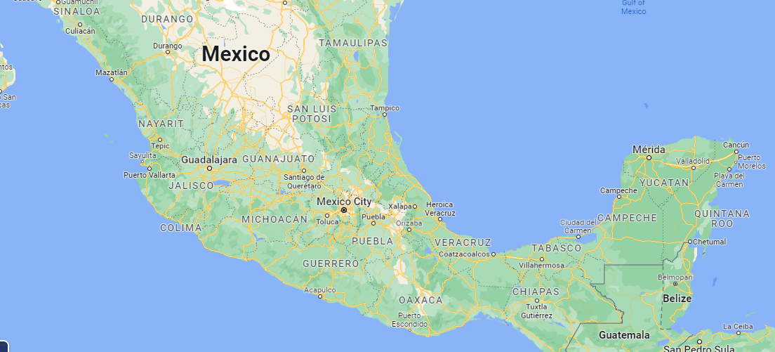
The impact of climate change is contributing to the spread of pests and diseases that can affect bee colonies and honey production. For example, warmer temperatures are allowing pests to spread more easily, while changes in rainfall patterns are affecting the spread of diseases. The impacts of climate change is also contributing to the fragmentation and overall loss of habitat for bees, which ultimately reduces their access to food and nesting sites.
Further along the supply chain, distribution problems are surfacing because the high honey season, which regularly begins in April to May started much earlier in 2022. Compounding this, Miguel Díaz Blasquez, an advisor to EDUCE explained that there was a global shortage of containers, causing delays to shipments.
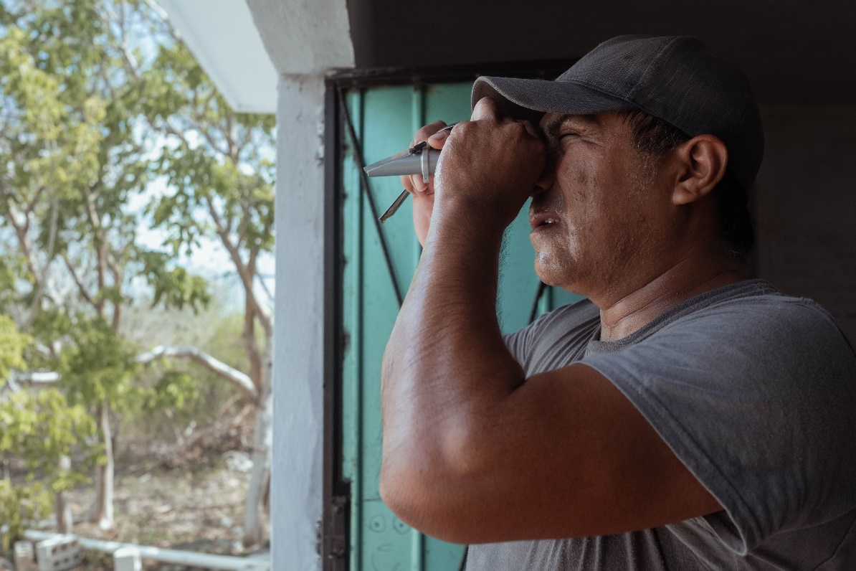
Mexico is also expected to be heavily and disproportionately affected by the impacts of climate change due to its complex climate and geography, exposing millions of people to acute food insecurity and reduce water security. According to the National Council for the Evaluation of Social Development Policy (CONEVAL), as of 2020, the poverty rate in the state of Yucatán has reduced from 53.3% in 2010 to the current level of 38.5%. This means that more than one-third of the state's population is living in poverty and this remains a significant challenge, particularly in rural areas and among indigenous communities.
A bee yard in Sudzal Yucatan.
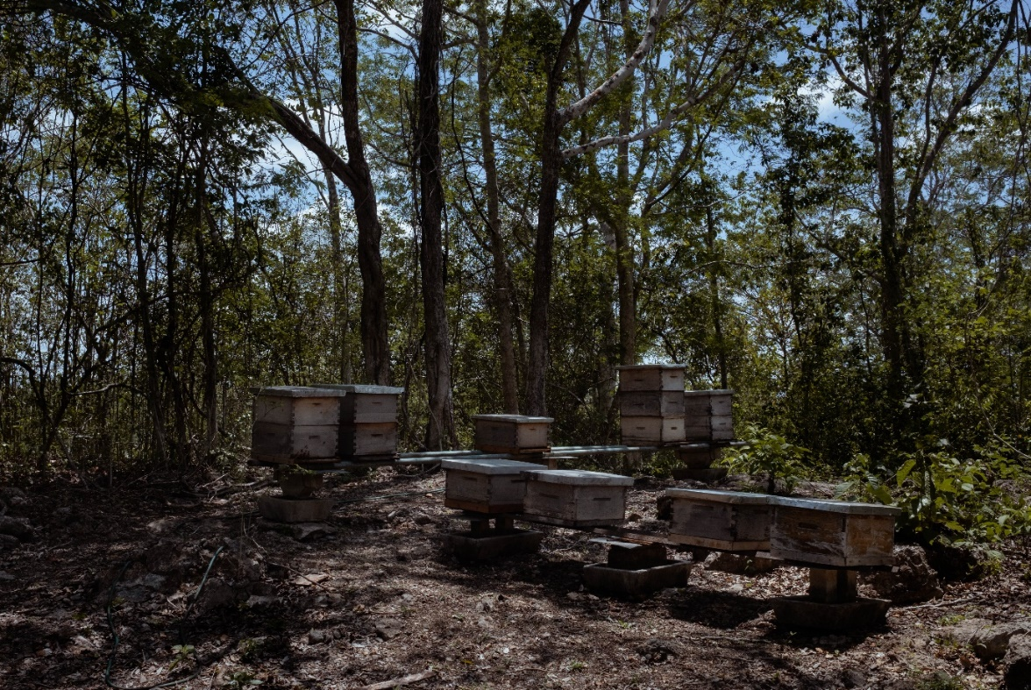
Diego Colli checks the density of water from a honey sample. Knowing how much water is in the honey helps the beekeepers to see how long it can stay fresh, the lower the water content the better the honey will keep.

EDUCE
Established in 1997, EDUCE Sociedad Cooperativa de Responsabilidad Limitada (EDUCE) is a co-operative dedicated to the production and export of Fairtrade honey. Today, EDUCE represents the voices and interests of 800 beekeepers in 40 co-operatives, across three states of the Mexican peninsula. Yucatán, Campeche and Quintana Roo (see map on page 6).
This area is known for its production of high-quality honey, particularly from the Melipona bee, which is native to the region. These bees are stingless and are known for their unique honey, which is prized for its medicinal properties and distinct flavour. Mayan beekeepers believe that these native bees were a gift from the god of bees and honey.
For nearly a decade prior to its establishment, EDUCE operated as Educación, Cultura, y Ecología (EDUCE AC), a local non-profit organisation founded by Mayan activists focused on health, agricultural production, gender and the environment.
The co-operative sought to support community development in the municipality of Hopelchén, located on the Yucatán Peninsula. One of their most successful initiatives was honey cultivation; the new co-operative offered producers training and technical assistance, helped the beekeepers construct sophisticated beekeeping facilities and produce
high-quality honey that steadily increased their incomes.
Although incomes improved, EDUCE were dependent on intermediaries to connect them to markets who often took a cut for themselves, leading to a smaller profit margin for their product. Reflecting on the honey production activities of EDUCE in the early 1990s, General Manager Miguel Ángel Munguía (pictured below) identified the main problem as the value chain, with ‘most of the value added’ having ‘gone to intermediaries, not to the producers’. At that time there were no farmer organisations successfully producing honey, so Miguel and his associates ‘started a new model for ordinary producers in terms of Fairtrade.’
Seeking to establish a better channel for commercialising the co-operative’s honey, Miguel sent letters to European buyers and also linked the co-operative to the growing fair trade movement, which guaranteed higher margins for co-operative members. In 1997, EDUCE’s first shipment of certified honey was sent to Europe and the co-operative achieved Fairtrade certification, affirming honey production as a viable means to supplement the income generated by subsistence farming.
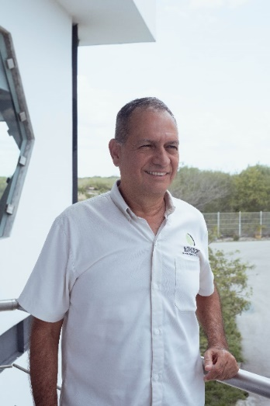
EDUCE currently has 15 employees, one-third of whom are women. Ownership is shared between eight associates: Miguel Ángel Munguía, Juan Ramón Prado Bustamante, Margarita Zarco, María Munguía, Hernán García, Azalea Calleja, Miguel Díaz Blasquez and Ana Patricia López. Miguel Ángel Munguía has lead EDUCE since its inception as Managing Director and legal representative. Miguel is in charge of commercial negotiations with buyers and also holds the position of Vice President of Fairtrade International as a producer representative. Miguel also sits on the Board of Directors for The Latin American and Caribbean Network of Fair Trade Small Producers and Workers (CLAC). CLAC is the co-owner organisation of the Fairtrade International system and the network that represents around 1,000 Fairtrade certified organisations in 24 countries of Latin America and the Caribbean.

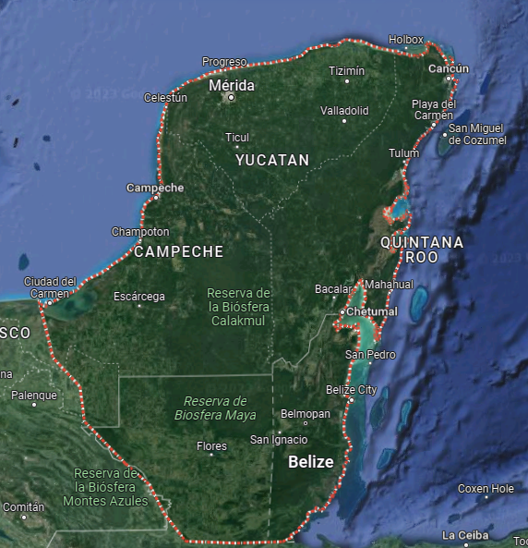
EDUCE co-operatives

Yucatán
Cantamayec 2 co-ops, comprising 27 beekeepers
Dzoncahuich 1 co-op, 24 beekeepers
Hocabá 1 co-op, 8 beekeepers
Izamal 1 co-op, 19 beekeepers
Maxcanu 1 co-op, 1 beekeeper
Mayapán 1 co-op, 7 beekeepers
Sotuta 1 co-op, 7 beekeepers
Sudzal 1 co-op, 15 beekeepers
Teabo 2 co-ops, comprising 14 beekeepers
Tixcacalcupul 2 co-ops, comprising 34 beekeepers
Tixmehuac 4 co-ops, comprising 37 beekeepers
Tizimin 1 co-op, 11 beekeepers

Highest concentration of beekeepers is in Quintana Roo, Felipe Carillo Puerto where 259 beekeepers are located
Largest co-operative comprises
137 beekeepers in Quintana Roo, Bacalar.

Quintana Roo
Bacalar 2 co-ops, comprising 139 beekeepers
Felipe Carillo Puerto 6 co-ops, comprising 259 beekeepers
José María Morelos 2 co-ops, comprising 84 beekeepers
Lázaro Cárdenas 2 co-ops, comprising 20 beekeepers

Campeche
Calakmul 8 co-ops, comprising 112 beekeepers
Hopelchen 4 co-ops, comprising 69 beekeepers

Business growth
EDUCE first became a Shared Interest customer in 2002 when they received a loan to prefinance honey orders; they held this first facility until 2005.
In 2015, we re-established contact with EDUCE and in 2016 they became a customer for the second time, receiving loans to prefinance their honey harvest.
EDUCE currently have both an Export Credit and a Stock Facility with Shared Interest. The Stock Facility is used to build stocks of honey from the producers and the Export Credit is used to prefinance honey contracts.
Shared Interest facilities

2018  Export Credit: £75k  Stock facility: £151k | 2019  Export Credit: £82k  Stock facility: £163k | 2020  Export Credit: £150k  Stock facility: £150k | 2021  Export Credit: £144k  Stock facility: £144k | 2022  Export Credit: £166k  Stock facility: £166k

Speaking about the benefits of the Shared Interest loan, EDUCE Commercial Manager Leonor López Garduza said: “It is used to pay the price in advance before and during the harvest when they hand over their honey. The beekeepers deliver their honey and also at the end, when they receive their extra pay because they have costs, they often use workers to help.
“The money allows the producers to continue with their business and it has a real impact. The money allows them continue with their work to maintain their families and to be productive members of society. Without that money, the producers would be at the mercy of other traders who are less ethical.”
Graph 1: Changes to the number of producer groups from 2015 to 2022
Shared Interest finance
Since working with Shared Interest the number of producer groups has increased from 63 to 113. EDUCE General Manger Miguel, explained the size of these groups ranges from 10 members to 140 members. He said: “Financing (from Shared Interest) has been key to increasing volume and growing.”
Speaking about the increase in producer groups he continued: “More producers want to associate with EDUCE given its fair price policy.”
EDUCE Plant Manager Juan Carlos Munguía said: “The investors can be sure that for the last 25 years EDUCE has been working in the Maya communities, meaning the very rural, very isolated traditional communities to support a better standard of living for them. It enables them to conserve their communities and the environment and the earth, and always to benefit them. I would say it is a link in the supply chain, it strengthens and benefits the groups and the producers and their development.
“It is consolidating and keeping together families and communities and giving them options for living. It helps to avoid them having to fall into worse things like drugs trade or other things so as to make sure that they have good options. So those communities, small communities don't lose their essence as indigenous or Mayan people.”
Miguel explained the fluctuations in the number of hives (as shown in the graph below). “The drop in hives is due to the effects of climate change. Rains, droughts, erratic flowering, deforestation, agrochemicals all have an impact.”
Each producer has an average of 35 hives. All hives are positioned within the Mayan jungle and the location has an impact on the volume of honey produced. Miguel said: “It is important in terms of pollination and increase of biodiversity. In protected areas and ecological reserves honey production increases.”
Graph 2: Changes to the number of hives from 2015 to 2022
Miguel told us “2018 was a record year for the collection and sale of honey”. Explaining this was due to higher demand from consumers.
Shared Interest finance
For the 2021 cycle, honey production increased by 50% because 52 producers joined the organisation. For 2022, honey production increased further thanks to favourable weather conditions. For the 2023 cycle, EDUCE foresees an additional production increase because ten big-volume beekeepers joined the co-operative.
Sales for 2021 increased due to the production growth and higher international honey prices. The sales achieved actually exceeded their original turnover forecast by 23% for that year. Sales for 2022 increased thanks to a larger production and a slight increase in honey prices. For 2023, EDUCE foresees a drop in sales because average honey prices are expected to decrease from 4.2 USD/kg to 2.5 USD/kg (40% less), due to adulterated honey driving down global honey prices.
Graph 3: Changes to the value of honey sales (USD) from 2015 to 2022
Shared Interest finance
Fluctuating honey prices are a challenge for honey producers in the region, with prices driven by demand. Miguel told us: “The fluctuation in the price is big, it's because the price is set by supply and demand that's what determines it and an important factor in it is adulterated honey. According to a study, one third of the honey in the world is adulterated. Most of it is produced, unfortunately, in China and a lot of that is consumed in the United Kingdom, so we're worried about that market. We're taking measures in committees and assemblies and we're raising our voice to get this resolved. The Honey Authentic Project is helping to raise awareness of this and resolve this problem. Netflix even does a series about adulterated products on the market around the world and one of those is honey (this series is called ‘Rotten’). So that's something that we have to work hard to fight.”
The Netflix programme investigates cases of honey adulteration, discussing how cheaper additives like rice syrup is added to honey to increase volume and meet consumer demand. It should be noted that worldwide honey consumption has been increasing in the last decade by around £40m annually, but production is falling. Experts suggest that this disparity is due to the volume of adulterated honey sold to the US market.
In our survey to beekeepers, we asked how long they had worked with EDUCE and how their production had changed. The graph below shows this correlation. The strongest connection is between beekeepers working with EDUCE for 2-5 years with a large proportion having seen their production increase during that time.
Graph 4: Changes to production over time compared with how long beekeepers have worked with EDUCE

Sustainability and impacts of climate change
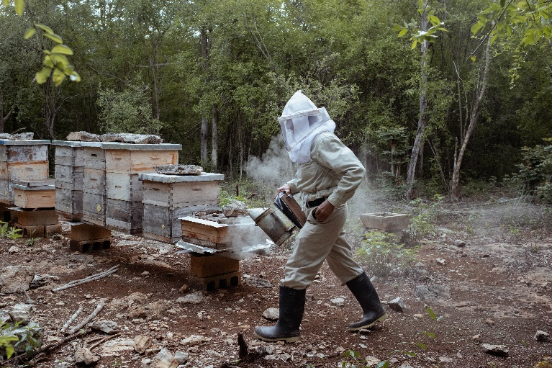
General Manager Miguel spoke of some of the challenges facing Mexican beekeepers. Most notably, these challenges focused on the impacts of climate change, deforestation and changes to farming practices in the region.
EDUCE have taken a strategic approach to growth by being proactive to climactic changes, which threaten to reduce production and cause changes to harvest seasons / periods which could affect their capacity to fulfil commercial and financial obligations. For example, the co-operative has changed the location of the apiaries that could be affected, promoted prompt communication with producers for honey collection activities, and signed contracts with buyers at the latest possible moment to ensure their production levels in advance.
EDUCE beekeeper Vitaliano Cahuich checks some of his beehives. He has assigned four different locations to hold the 70 beehives.
It is a common practice among beekeepers to establish their apiaries in different places in order to take advantage of the various blooms that occur throughout the year. Vitaliano takes advantage of the bloom that occurs in the milpa, in the areas of high forest and in those of secondary succession (forest in recovery).
Speaking about the impact of climate change, Miguel said: “Change of dates in the times of flowering, rains and droughts in excess, hurricanes or winds in excess. Climate change has affected us in the past, there was a very marked period of flowering when the plants and trees flowered. We're in a forested area here, and there was always one flowering in January and other in February, another in March, another in April, another in June, and it was very marked. Nowadays, the flowers that were meant to come out in February don't open till June or don't open at all. In which case there's no nectar, and then the ones that were supposed to have opened later, opened early or not at all. So there's no nectar. Another is the either excessive rain or drought, hurricane type winds or hurricanes, and there's also the threat of deforestation in the Peninsula which is very rich in water resources.”
EDUCE Plant Manager Juan Carlos Munguía said: “We have seen the impacts of climate change. The Mayas, that's the indigenous people traditionally had knowledge that the beekeepers had, a deep knowledge of the countryside and of the cycles of flowering, so that they could predict a stable harvesting time and seasonal changes. They could expect those things, but all of that stable standard has moved, and now we don't know when the countryside will flower. There's rain out of season, there's cold out of season, or the flowering is accelerated. There is an impact on production and on the beekeepers and on the beehives. There hasn't been so much consumption of honey and that has an effect back onto the producers because of course the produce doesn't move and there are warehouses still full.”
EDUCE offer their beekeepers training to mitigate against some of these impacts. Miguel told us: “We’ve done workshops, we've had meetings with the farmers about climate change. We've had discussions and talks on problems around global warming and climate change, and we've taken measures with the producers, for example, on repositioning their hives. The Peninsula is flat and so when there's heavy rain, there have been times when the hives have been flooded. So we've been promoting the idea of the producers moving their hives to higher ground or to places, at least where traditionally there isn't any running water if it does rain heavily there and the flood water doesn't affect it, that's one thing.
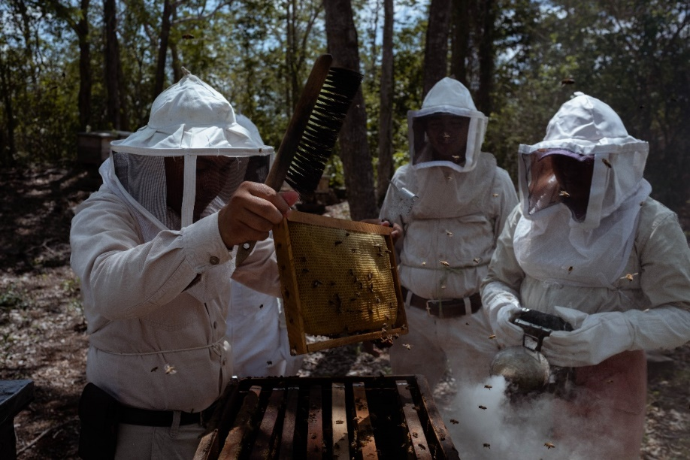
“Another is to promote healthy, strong hives that are well fed, that have a young Queen and new wax. Those are more resistant to climate change and also at the end of the harvest there's usually some honey. That's too damp for the market - we leave that in the hive as food for the hive. This wet honey is put into stock and stored to use against climate change in case there's a need for it, we can then use as food for the hives. For example, we had an instance where high winds blew the flowers off the trees and therefore blew the nectar off the trees and we were able to use that reserve of wet honey as food.”
Wet honey
Honey with a moisture content of above 20% can ferment. High moisture honey is often seen in especially wet springs or humid areas, if honey is harvested too early, or water was introduced during extracting.

Jorge Luis Chan son of Jorge Humberto Chan, works with Jose Alvaro Catzin and María Sujey Tun in the harvesting process.
EDUCE currently offer beekeepers the following training:
- Bee feeding
Bee feeding provides the bees with food during periods of pollen and nectar scarcity. Organic standards only permit providing them with these sources of food, ruling out substances such as sugar or other energy and protein sources.
- Beeswax stamping
- Good beekeeping practices for sustainable apiculture
- Hive care
- Internal Control System (ICS) for organic certification
- Honey product diversification and trainer formation
Beeswax stamping - Due to the prevention of using commercially sourced wax for beehives, it becomes necessary to use wax produced by the hives themselves.
- SWOT analysis: assessment of weaknesses, strengths, threats and opportunities for honey production & conduction of action plans.
- Care/conservation of hives with sulphur
Sulphur is used as a means to prevent hives, or more precisely, the stored combs, from being attacked by moths, as an alternative means to insecticides.
- Hive management
- Wax processing on behalf of others (wax milling)
We surveyed 120 EDUCE beekeepers, 68% said they had accessed some of this training offered by EDUCE. Fifteen per cent stated they had benefited from an income diversification project, such as growing vegetables or fruit.
EDUCE beekeeper María Colli, said: “EDUCE have trained us to keep containers full of honey aside to feed the bees. That's something that they've taught us to do and that when we do not have enough money to do it, they actually given us the honey to keep too.”
Producers were also asked about changes to their income since joining EDUCE. The graph below compares years involved with EDUCE against changes in income levels.
Graph 5: Changes to income over time compared with how long beekeepers have worked with EDUCE

Miguel also spoke to us about changes to farming practices happening in the region, which threaten the future of organic beekeeping. He said: “There are monocultures coming in that use chemical products in which they cut down the forest, they deforest the area. The Mennonites came to Mexico 100 years or so ago and to Yucatan 40 years ago, they use technologies from the era of the period of the Green Revolution, using agrochemicals. They farm intensively and they're not particularly enamoured of the biodiversity and the environment. They have financial backing, they have financial power and they've bought land, they, they've deforested it, and they use it to grow maize, watermelons and other things. There have been conflicts and disputes and negotiations. For example, a few years ago they were authorised to plant transgenic maize and we fought against that. Through political means, and we had it stopped. They are suppliers on a large scale of pork. So they farm pigs on a large scale and pigs need soya for food. They produce their own soya and this has a knock on effect in the pork market.”
National Geographic published an article in 2019, stating: ‘Since the 1930s, Maya beekeepers have made the Yucatán Peninsula - covered with the largest remaining tropical forest in Mexico, sacred cenotes, and endangered wildlife - into a world-class honey producer. But the rapidly expanding presence of Old Colony Mennonites, who are transforming large swathes of land into agricultural fields, could change that.
‘Beekeepers say that the large-scale agriculture and the genetically modified soy, also called transgenic, planted by the Mennonites is killing their hives and contaminating the supply of honey with pesticides.’

Social impact
By offering beekeepers a higher price for their product, they are incentivised to join EDUCE, helping to reduce rural-urban migration and out-migration to the United States. On this topic, Miguel said: “This has been very helpful to preserve the social fabric of our communities.” Fairtrade certification has also enabled EDUCE to provide up-front working capital to its farmers, rather than awaiting final payout once their raw honey has been processed and exported, allowing investments in new beehives, agricultural inputs and the covering of other essential costs such as education, household sanitation, and healthcare.
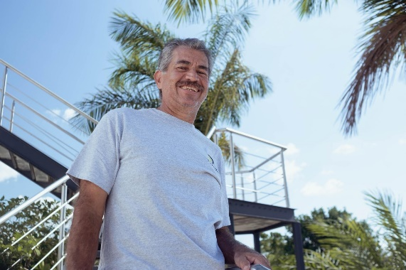
EDUCE also help to defend the territories and culture of the region’s indigenous Mayan population. Miguel said: “Since the bees have no borders, a protection to the forest of around two million hectares is needed,”
EDUCE Plant Manager Juan Carlos Munguía (pictured right), said: “In the time EDUCE has been formed, it has narrowed the space between the beekeepers, the producers and the clients. So the price we can get is as good as it can possibly be because there are no intermediaries. And then at the end of the year, we have a profit, a leftover amount that we can pass on to the beekeepers.”
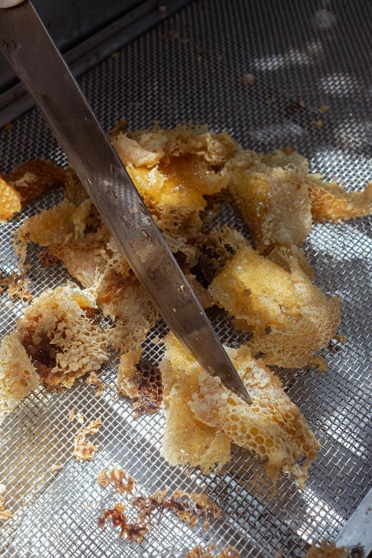
Juan told us about the challenges beekeepers have been facing. He said: “The main challenge is that the honey is bought up by bigger companies who buy it and sell it on without acknowledgement to the small producer. We call them coyotes. They don't recognise the producer. So what EDUCE tries to do is to support them with training, equipment and projects, helping them with organising themselves. We also work with external agencies like the United Nations Development Programme (UNDP). We support them (the beekeepers) with the harvesting and also with gathering their produce together. Because they're organised in
co-operatives, the challenge is to get more and more beekeepers on board.”
The collaboration with the UNDP enables EDUCE to offer training and advocacy actions in defence of beekeeping. Additionally, the Small Donations Program has supported both EDUCE and some beekeeper co-operatives to strengthen their infrastructure.
Juan continued: “The honey we make is organic, and so we want to see them benefit from that, and also from Fairtrade which we work through and we want their work acknowledged and to support their development and to do what nobody else does, which is to hand on to them the profit at the end of the year. Once the admin is done and we've worked out all of our expenses for transports and imports and all the rest of it, when there's money left over at the end of the year, we have assemblies with each group. We have committees that get together because we believe in clear accounting. We show what we've done and what we've earned and we hand on the extra value to the beekeepers by way of paying them more for their produce than they would have got elsewhere.”
When the honeycomb starts to lose its shape the beekeeper reshapes it by manually cutting it.
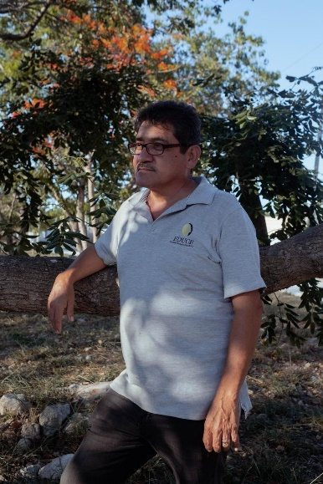
Miguel Díaz Blasquez (pictured right) works with EDUCE in Internal Controls. He has been involved in beekeeping for over 30 years, talking about the changes he has observed during that time, he said: “In terms of economic, financial terms and also in terms of housing for the better, we've seen a change from hard earth floors to cement floors and with the resources that they've been able to achieve from the production and sale of honey as an activity. There are other economic activities, but honey is a complementary activity to their income.
“The credit from Shared Interest is very beneficial because it's timely, we can get it to the producers quickly to allow them to gather to harvest the honey and for them to be paid. The benefit goes straight to the producer and the timeliness of the payment allows better results.”

My story: Andrés Munguía Zarco, Treasurer

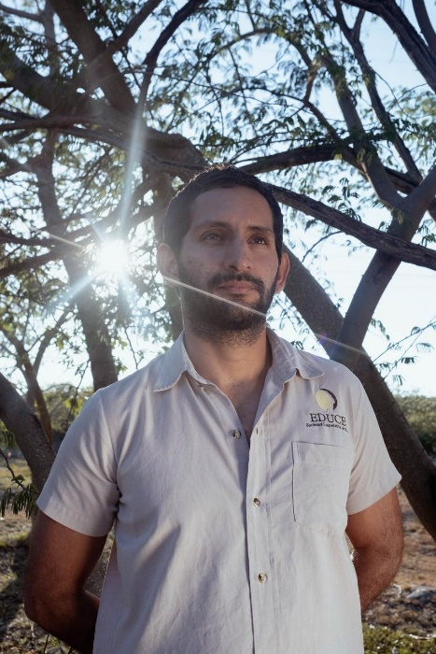
Andrés lives in Merida, the capital city of the Yucatán state in southern Mexico. EDUCE are also located in the same area. Andrés said: “I work in the commercial area and have worked here for five years. I'm in charge of the relationship with the customers and also for the relationship with the beekeepers. I am the key person in terms of commercial relations. So the collecting of honey and all the payments to the beekeepers and also the payments in general.”
Andrés spoke about the benefits EDUCE offers to beekeepers, he said: “The price is the most important, because since almost all of them are organic beekeepers, we try to pay them their highest possible price. What we do is that we pay the price that is on the market during the harvest and by the end of the year, we try to level up all the prices to the highest possible. For instance, if we pay now 35 USD and then at the end of the year we can pay them all up to 50 USD, we give the difference to them, and that's the main benefit. While there are also of course, other benefits are the health and environmental benefits that come together with organic beekeeping.
“There is also a benefit of the training and access to some other projects that we do. We work with several co-operatives to help them improve their infrastructure.
“We are seeing improvements in the income for the beekeepers. We can also see improvement in the infrastructure from the collecting point. There is also the fact that many people don't have to migrate if they can earn a living here, they can stay and then the families keep together in their communities. You also see some of them are able to better educate their children. We have some beekeepers that can now have their children in the university which that they couldn't before. You can see also some improvements in their houses I would say.”
Andrés told us the threat of deforestation, impacts of climate change and fluctuating honey prices are causing challenges for the beekeepers at EDUCE. He said: “Well, of course there is always this threat of deforestation in some areas or crops that are not organic, that might threaten the environment here. There is also climate change, the rainy season is changing. Sometimes we don't know if we will have enough honey harvested, and also the honey market in the world is not steady. For instance, this year the price really dropped compared to last year, which is really bad for the beekeepers because they do the same work for half the price they used to get last year. Unfortunately there’s nothing we can do because the clients in Europe don't pay, they also reduce their prices. We cannot do anything to do manage that, so I think that's also an important challenge, because many beekeepers get demotivated.
“The organic beekeeping involves more work, and the risk if the prices are low then the beekeepers think it is not worth doing all these extra things to stay organic as they are not getting a higher price for their honey.”
EDUCE currently export to Europe and are exploring possibilities to expand in to other markets, the US market in particular. They are also looking to expand in the local market. Although Andrés told us “the local market is not that big or strong”.
EDUCE are currently using a Shared Interest loan for the payments to the beekeepers. Andrés told us the loan is used before and during the harvest so they can pay the beekeepers during the harvest. He said: “We would like to thank Shared Interest investors for helping us to get the loans because we really do need them to keep collecting honey on time, in order to have the honey which we later sell.”

My story: Juan Orcanza, Finance Manager
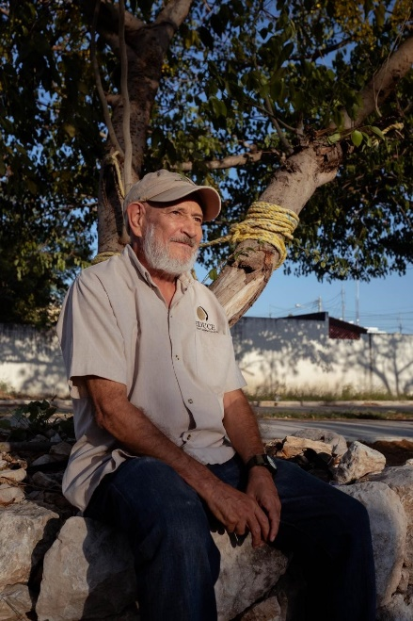
Juan has worked with EDUCE in the financial area for 12 years. He said: “My work at EDUCE is very varied. One thing I look after is projects, as and when those are going on. I have to call meetings for donations, for example, donations from the United Nations. I also prepare budgets, and when that's approved follow up with implementation. I have to manage credits for example, with Shared Interest. And I look after financial projections, pulling information together to make financial projections work together. I work on the exercise of credits and payments, so I work closely with the accountants. The second thing I look after is training of the beekeepers. I coordinate and direct training. There has to be a system. We have 800 beekeepers among whom we cascade training.”
Juan spoke about the changes in the community over the last 10 years. He said: “Changes have happened in the community I live in. It's not a small community. I live in the city of Merdia and there's been a lot of growth, a lot of population growth and a lot of immigration from other towns in the country. In the small communities where we work, there has been change. For example, when I started with beekeeping there was only a very small participation of young people and women. But both groups are now visible in the co-ops. There was less awareness of the environment.
“The communities themselves have grown. One important change since the pandemic is the widespread use of the internet connections. Four or five years ago, there was much less internet, but now most people have it and people have learned to use it, which is an important cultural change. We've been able to survive and we've been able to face the tropical storms.
“The sad changes are that young people aspire to emigrate from the countryside and live outside their communities. They forget their language and don't have an interest in beekeeping or working on the land.
“Growth is one of the things that has been a challenge over the last five years. The number of beekeepers, it's been difficult because we need more finance, more logistics, more processing. We need to learn how to be bigger. Secondly regulations, there needs to be better regulations, so both our clients and the regulations have become more demanding over the years. Every year they are more demanding, which means for us to train the beekeepers so that they can meet the requirements appropriately.
“A third one is financing management of cash flow during the harvest, especially in a changeable market. In 2022 we had very high prices, this year we've got very low prices - it's a changing market due to the logic of a global market. So the challenge is to work in to maintain healthy financial condition, and continue to offer the best price to the beekeepers, which is the overall goal.
“The market is unequal. It's an uneven, unequal market and the offer depends on climate. If a country has had good weather there's a lot of money on offer. And in a year when the weather is bad in particular countries and the climate there effects, production reduces. So with lower production the price goes up because there's the lower production, there's less money available. So the price is higher. This year there's been a lot of Ukrainian honey on the market with lower, lower taxes applied to it, and so when a lot of honey floods the market, that affects the price.”
Speaking to us about the Shared Interest loan, Juan told us: “The Shared Interest loan goes towards paying the co-operatives. The co-operatives get their honey from the producers and hand it on to us. So it's extremely important that we have money available at that time to pay them for it. In the logic of the producer the money is more important to have, he wants to be paid in hand at that time. This is even more important than longer term gains because he has costs, he has immediate costs that he needs to pay. So and if an organisation doesn't have money to pay him he will just go and sell his honey outside the organisation. So it's very important to us. For example, if there is one day delay in payment that can lose 600 to 1,000 kilos of honey.
“It’s very important for us to have funding from Shared Interest because it resolves our need for payment to the producers compared with other institutions it's cheaper for us to borrow. The interest rates are more attractive for us, and that means that we can then give the producers a better price.”

My story: María Colli, Beekeeper

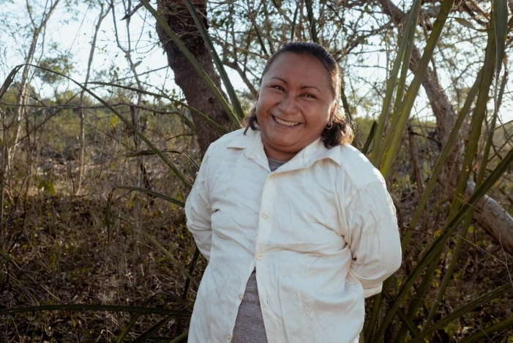
María Colli has been an organic beekeeper for four years. She lives in Izamal in the region of Yucatán, Mexico, with her husband who is also a beekeeper and two sons.

María said: “Beekeeping is not our only form of income and it's certainly not enough to cover the needs of the house. My husband is a beekeeper, but he also works. I'm a beekeeper and I sell food that I prepare food at home. I drop the boys to school and then I come home and I cook. So I've got that and the bees, of course. And the same thing with my husband. To earn an income completely from beekeeping we would need about 60 hives, really, but we don't have that many. I have eight and my husband has 40.

“We also need honey as food for the bees themselves because we're organic and we're not allowed to use sugar or other kinds of food for them, we have to use the same honey that we produce. So we keep parts of that; about two buckets full to feed to them, so that they may be healthy when there's a drought. We keep two lots of 25 kilos of honey aside to feed the bees.”
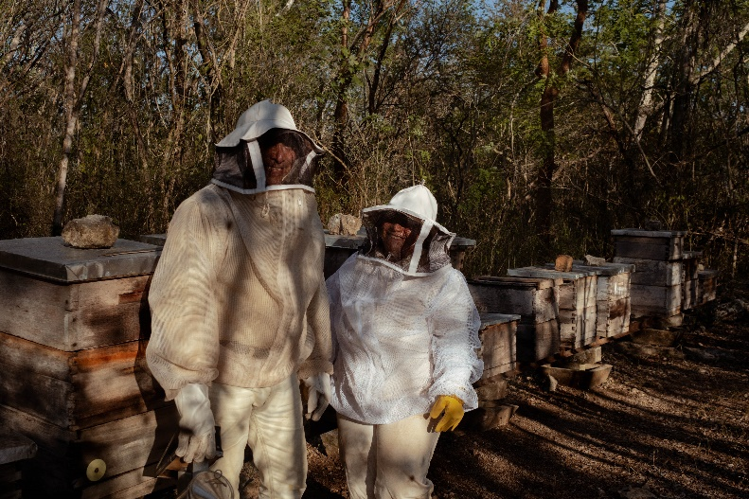
Speaking about becoming a member of EDUCE, María told us: “The motivation why I was interested in joining with EDUCE was the price. It's a good price for us. And the other thing is that they give us workshops, they run workshops for us on gender and on the environment.

“The big change for us has been the price EDUCE offers, but also, the workshops have been a big help for us. This is very small town village and with a fair bit of machoism, and so these workshops they've opened our eyes perhaps. It's a pleasure for myself and the other women to have them. We used to be embarrassed to voice opinions or to speak up or we were shy but not anymore.
María pictured with her husband Diego inside María's apiary. Even though they both are beekeepers each one has their own colonies to take care of but they find times to work together and help each other.

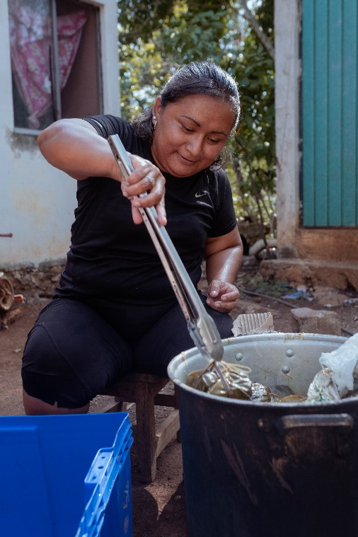
“EDUCE have shown us how to diversify our products, make other uses of our products and more than anything, it's given an opportunity as women specifically, before you didn't see any, there was no such thing as a woman beekeeper. But now there's myself and my group, we've been the first and there's another group forming as well.”

María told us that the impacts of climate change are a challenge for the beekeepers. She said: “The climate is a challenge, hurricanes especially. It's an annual thing that's always been there. Over the last five to 10 years, it has got worse. The droughts are longer. The effect is a lot. The bees need water to drink water, and there's no water nearby. We have to carry big plastic containers every couple of days to the hives and we put it in troughs for them, because otherwise they die. Lots of them have died already. The other thing is flowering. There's no flowers on the trees because of the drought. You can see where the flowers are budding and trying to come out but they just dry up.”
María checks the tamales she recently cooked. Besides being a beekeeper María sells tamales to bring extra money to the house.

Speaking about her plans for the future, María said: “I would like to get more hives and diversify my produce. We are very happy working with EDUCE, they've helped us a lot. They've helped us to learn. They give us these workshops on how to make skin creams, on how to make throat sweets, and also cough syrup which is really good.”

My story: Jorge Alberto Chan López, Beekeeper

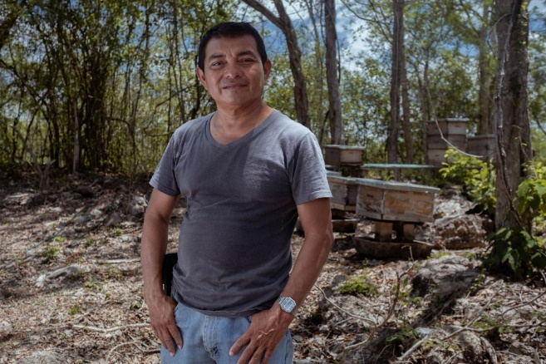
Jorge Alberto Chan López has been a beekeeper for 25 years, and has worked with EDUCE for 12 of those. EDUCE helped Jorge set up his beekeeping co-operative, Xjohn-Ha’ac de Sudzal S.C. de R.L de C.V., which shares the name of a climbing plant.

Jorge said: “The economy of being a beekeeper isn't 100% enough to cover the needs of the household, for food, school, those things. So I get 80% of my income from beekeeping and then another 20% from other agricultural activities to complement the rest of the income.

“We practice traditional farming the same as our ancestors did. Organic farming, we take a lot of care that it's clean, we don't use any chemicals. It's very small scale, we grow corn, pumpkins, and chillies on our own family plot for consumption at home, for ourselves.”

Jorge told us he currently has 120 hives which he owns. He said: “I find it very beautiful keeping bees. I'm passionate about them and the work that they do. And what they give us as families, they give us food and a livelihood.”

Jorge told us one of the reasons he decided to join EDUCE was the price they give for the sale of honey. He said: “The market rate is very unstable and sometimes the market becomes saturated. So we joined EDUCE because there are very responsible and they always give us a good price, always above the going rate in the local markets.”

Jorge told us that he has received technical training on beekeeping. He said: “We have had specialist experts who have supported us in every aspect of the care and management of bees and in best practice, and how we can improve our work.”

Speaking about the impacts of climate change, Jorge said: “Climate change has been affecting us for several years now and it affects the harvest, for example, this last harvest has been very low, the yield has been very small. Because nowadays rain falls when we don't need it and when we do need it, the rain doesn't fall. Those cycles have changed, and the other thing that has changed is the cycle of flowering of the plants and trees.

“Some plants flower ahead of when they ought to and some flowers and trees flower behind at later than planned. In the past we used to know the cycles, we knew exactly that between December and May-June, that would be the harvest. But nowadays it's changed this time. For example, this year it was February to April. Which is much shorter and the wrong time of year for what it should be, and we were only able to take three harvests of honey instead of what should be six or seven.

“EDUCE has provided training, particularly about how to face the problems of climate change. In particular, here in Yucatán we are very exposed in our area. We're very exposed to hurricanes and natural disasters, which you can't avoid, but they've taught us how to plan in advance for when there might be a big one. EDUCE is very good and very aware of the wellbeing of the bees and also the members of the co-operative.”

Speaking about plans for the future, Jorge told us: “We always think about moving ahead slowly one step at a time moving forward, improving the production, improving our beeping methods, taking care of nature. As well as resolving those kind of problems that we can to improve the natural environment. Obviously there are some things that are beyond us that are out of our control. But in working to improve what we can and because we work with an insect, the most productive insect for food and livelihood. It's a natural pollinator so we look after it, it doesn't do any harm to anything. It helps us, and we and we work to protect it. We also aim to learn more, produce more and take care and produce the best quality honey we can.”

Plans for the future
When looking to the future of EDUCE, General Manager Miguel identifies two key priorities. The first centres around growth: to continue expanding its existing membership of 800 local beekeepers to include more of the 18,000 apiarists in Yucatán, Campeche, and Quintana Roo. “To grow, it is necessary to expand our line of credit and some subsidies to improve the infrastructure,” summarises Miguel.
The second priority is to uphold and implement the co-operative’s core values. By advocating for an end to deforestation, greater land protection, and the prevention of pesticides, EDUCE is protecting local ecosystems and the environment on which the well-being of its business and members depend.
Miguel said: “There are several ways that we can achieve this. One is that we need financial resources, capital and in our area infrastructure for processing of honey needs, we need improvements. We need more solar panels for generating electricity. We have two sources of electricity. We have the standard local traditional source of electricity, but we also have our own solar cells to generate our own electricity to lower our costs and therefore allow us to offer a better price to the farmers. So infrastructure.
“Secondly, new markets we used to sell in the US and in Europe, we now only sell in Europe. So we're exploring new markets to regain the USA and also expand to Saudi Arabia. So diversification of clients and then the third one would be to attract more beekeepers. In the region there are around 18,000 beekeepers, most of them are not in
co-operatives, they're not organised. They work individually. And we think that
co-operativism is a good option. We have under 1,000 beekeepers organised with us, so that means there are other 17,000 to that are out there to help us grow. However, we don't want a monopoly. We're not after that, but we see that there are advantages as a producer to being a member of our organisation. We offer high prices and a lot of collateral advantages, for example, and avoiding farmers leaving, migrating away from the area, and also at the level of the family. So we offer a lot of collateral advantages.”
Juan Carlos Munguía added: “The future plan is to continue to grow more and bring more benefit to more beekeepers. We're a small company, there are only 20 direct collaborators (employees) at the moment. So it's a little bit difficult. We've improved the plant over the last years and made changes there, although again that still needs more investment to allow for bigger infrastructure for growth. So that would be the challenge in the plant at the level of beekeepers. To grow, a lot of people come to us and who know about us, come to us to join - a lot of beekeepers and organisations. So the challenge is to get into more markets, to bring more benefit for the beekeepers through fair trade. For additional benefit, we've now got a network of co-ops. We are becoming stronger through being united in order to sell our Fairtrade or organic honey.”

Conclusion
It is evident that beekeeping in the Yucatán Peninsula of Mexico is a fundamental source of income for rural farmers. The EDUCE co-operative is dedicated to the production and export of Fairtrade honey. Today, EDUCE represents the voices and interests of 800 beekeepers in 40 co-operatives, across three states of the Mexican peninsula. Founder and Managing Director Miguel has ambitions to grow further, he told us: “We have under 1,000 beekeepers organised with us, so that means there are other 17,000 to that are out there to help us grow.”
The honey market is volatile with prices changing from year to year, affecting the price beekeepers receive for their product. EDUCE mitigates these fluctuations somewhat by offering beekeepers a higher price for their organic and Fairtrade honey. The impacts of climate change are having a negative effect on the work of the beekeepers, causing change in flowering seasons for nectar. EDUCE are offering training to beekeepers to mitigate these risks and better manage their honey production.
EDUCE are promoting gender equality, one third of employees are women. Juan Orcanza has worked with EDUCE for 12 years, He said: “When I started with beekeeping there was only a very small participation of young people and women. But both groups are now visible in the co-ops.”
Beekeeper María Colli, said: “EDUCE have shown us how to diversify our products, make other uses of our products and more than anything, it's given an opportunity as women specifically, before you didn't see any, there was no such thing as a woman beekeeper. But now there's myself and my group, we've been the first and there's another group forming as well.”
Shared Interest finance has enabled EDUCE to stock honey from producers and to prefinance their honey harvest. This finance has allowed the co-operative to pay farmers all-year round for their product, building their resilience by providing a stable income. Without this finance and the membership of EDUCE beekeepers would be at the mercy of middlemen paying them a lower price for their honey. The loans EDUCE receive from Shared Interest are enabling the co-operative to pay farmers all year round for their produce as well as securing important honey contracts to allow the co-operative to sustain and grow.
Beekeepers to better support their families, adapt to the impacts of climate change and manage the fluctuating honey market thanks to EDUCE and the support from Shared Interest.

Glossary
Adulterated honey
Adulterated honey is honey that has been mixed with some other substance; usually a similar, but cheaper, sweetener like corn/rice syrup or sugar.
Apiary/apiaries
An apiary/apiaries are a place where bees are kept; a collection of beehives.
Ecological reserves
Ecological reserves are areas selected to preserve representative and special natural ecosystems, plant and animal species, features, and phenomena.
Export Credit
Financial product designed for producer organisations to provide them with sufficient working capital to complete and deliver new orders or contracts.
Fairtrade
Fairtrade is used to denote the product certification system operated by Fairtrade International. When a product carries the FAIRTRADE Mark it means the producers and traders have met Fairtrade Standards.
Fair trade
Fair trade is a trading partnership, based on dialogue, transparency and respect that seeks greater equity in international trade. It contributes to sustainable development by offering better trading conditions to, and securing the rights of, marginalised producers and workers.
Maya / Mayan
The indigenous people of the Yucatán Peninsula of Mexico. "Maya" is a modern collective term for the peoples of the region.
Milpa
The milpa is a traditional Mesoamerican agricultural system that relies on a polyculture of domesticated plants, including corn, beans, squash, and chili, and integrates various activities such as cattle raising, beekeeping, and more.
Prefinance
Prefinance takes place when a financial institution advances funds to a borrower based on proven orders from buyers. The borrower usually requires the funding in order to produce and supply the goods. One of the key reasons for prefinance is so that the borrower has sufficient working capital to enable them to complete and deliver new orders or contracts.
Protected areas
Protected areas are special areas for locating beehives away from the use of pesticides.
Stock Facility
A type of loan from Shared Interest to secure stock when harvests are unpredictable and contracts have not been finalised.
Tamales
Tamales are a traditional Mexican dish made with a corn based dough mixture that is filled with various meats or beans and cheese.
Technical Assistance
The process of providing targeted support to an organsation with a development need or problem, which is typically delivered over an extended period of time.

Appendix 1: Producer survey
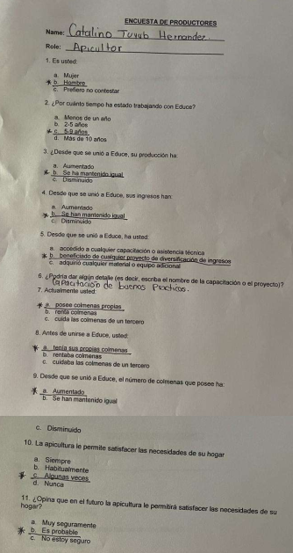
Sample of Customer Survey.

Appendix 2: Sample interview questions
Questions for producers

Please tell me about yourself
- Name
- Which village / community do you live in?
- Who do you live with?
- How do you earn an income?
- How regular / reliable is this income?
- Is this income sufficient to meet all of the needs of your household? (food, school fees, healthcare etc)

Please tell me about your experiences as a beekeeper
- How long have you been a beekeeper?
- How many hives do you have?
- How satisfied are you with your beekeeping activities?

Experiences as member of Educe
- How long have you been a member of Educe? 12 years
- What was your motivation for joining Educe?
- Has your life changed since you became a member? If yes, in what way?
- Have you received any training / support from Educe? If yes please describe this support and the impact it had on your farming business
- Are you / your community involved / benefitting from any of Educe’s social impact projects / other activities?

Have you observed any changes in your farm / production over the past 10 years? If yes please describe these changes. What do you think has caused these changes?
- What have been the main challenges facing your farming business over the past 10 years? How have you adapted / recovered from these challenges?
- Do you grow any other crops? If yes, what do you grow? What proportion do you sell / eat?
- Do you practice organic farming?
- Are you able to access all the required inputs for your farm? e.g fertiliser?
- Has your access to inputs increased / decreased over the past 10 years?

In your opinion, do women face specific challenges in farming?
- How is access to land like for women in the community?
- Do women in your community face specific challenges regarding farming? If yes, please describe these challenges

Have you noticed changes in the environment / climate in your region? If yes, have these changes impacted your beekeeping?
23. What are the environmental challenges facing your region?
24. Have you noticed the environment / climate in your region changing over the past 5 – 10 years? If yes, please describe these changes.
25. What is the impact of these changes on life in your region?
26. Have you received training or support to increase your resilience to climate change?

Have you noticed changes in your community over the past 5-10 years? Please describe these changes

What are your plans for your future?

